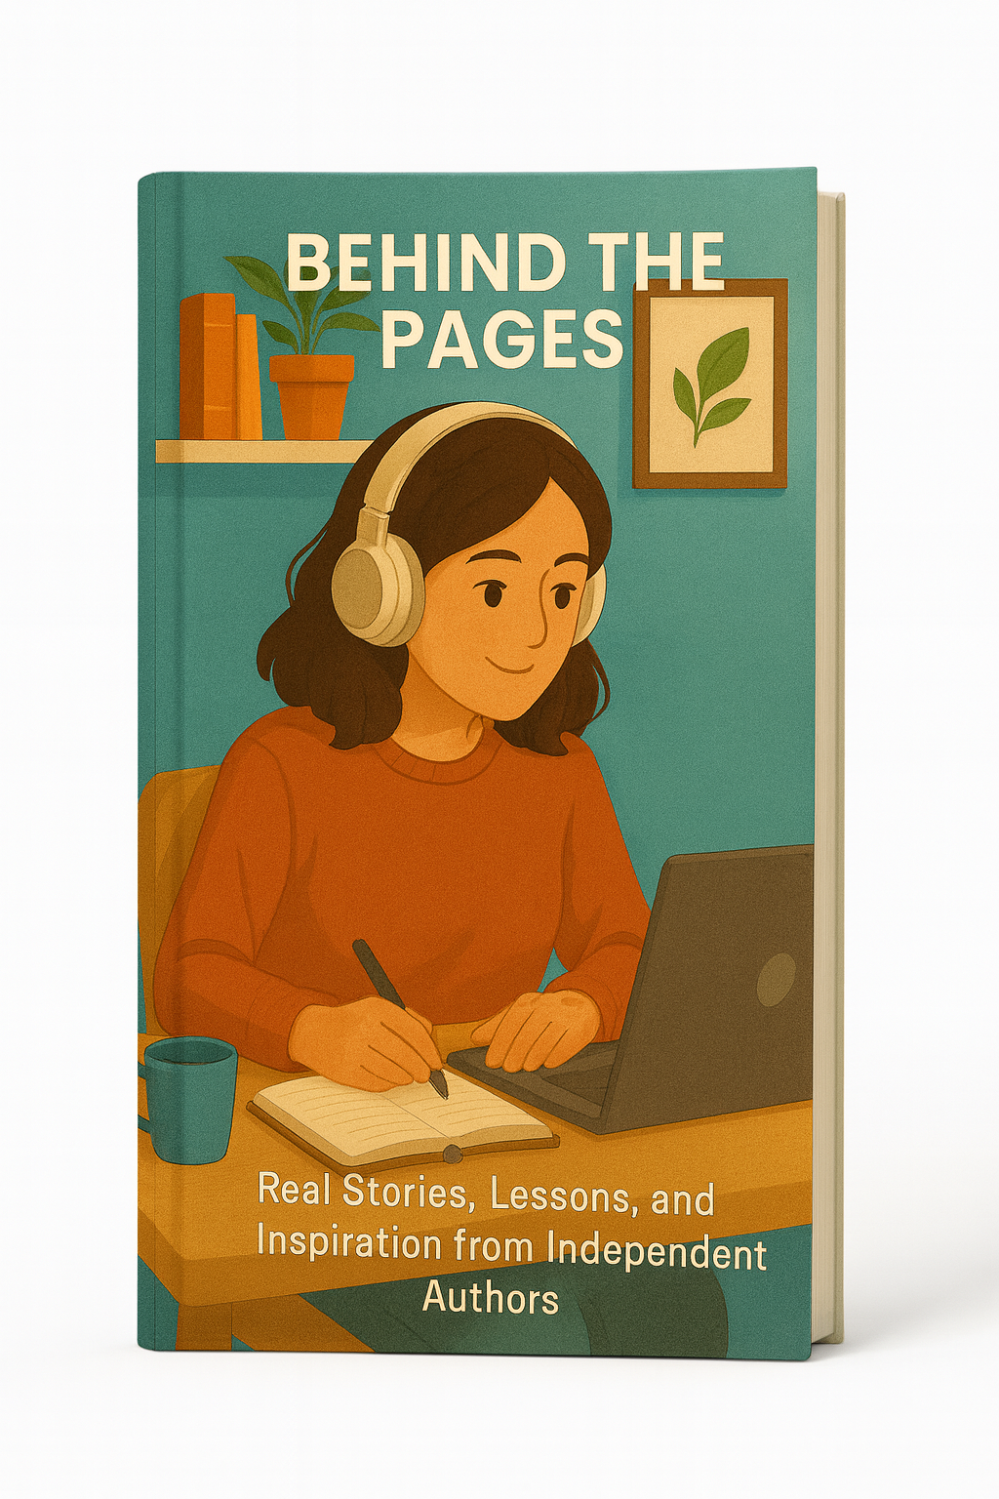

Behind the Pages

Real Stories, Lessons, and Inspiration from Independent Authors

Table of Contents
Introduction – The Quiet Work You Never See 3
Chapter 1 – Where Books Really Begin 4
Chapter 2 – Writing Around Real Life 5
Chapter 3 – Drafts, Doubts, and the Art of Starting Over 6
Chapter 4 – The Moment of Letting Go 7
Chapter 5 – When Readers Answer Back 8
Chapter 6 – Why Independent Voices Matter 9
Final Note – From the Other Side of the Page 10



Introduction – The Quiet Work You Never See

Every finished book looks simple from the outside. There is a cover, a title, a name on the spine, and a clean button in an online store that says “Buy now”. From that distance, it is easy to imagine that the book arrived in the world almost fully formed, as if the author sat down, wrote a few brilliant pages a day, and watched the story unfold exactly as planned.
Reality is far less tidy. Behind every independent book there is a life that has been rearranged, a schedule that has been bent out of shape, and a long series of decisions that almost no one will ever see. There are early mornings and late nights, tiny victories and quiet doubts, stubborn pages that refuse to cooperate, and whole chapters that vanish in a single click because they were not good enough yet. There are moments when the author is convinced the book is worthless, followed by flashes of certainty that keep them going.
This short book opens a door to that hidden process. It does not focus on celebrities or overnight bestsellers. Instead, it follows the more common path: the writer who works a normal job, has real responsibilities, and still finds a way to bring stories and ideas into the world. Some examples in the following pages are composites, woven from many voices and experiences, but the emotions are real. So are the lessons.
You will not find a rigid formula for success here. What you will find are honest glimpses of the creative life behind independent books: where ideas really come from, how drafts evolve, what happens when a project seems to fall apart, and why so many writers keep going even when results arrive slowly. If you love reading, this is a way to deepen that love. If you have ever thought, “Maybe I have a book inside me,” these pages may help you treat that thought with more respect and a little more courage.

Chapter 1 – Where Books Really Begin

Most people imagine that books begin with a single perfect idea. The author suddenly knows exactly what the story will be, or what message the non-fiction book will deliver. In truth, many books begin with something smaller and more fragile: a moment that refuses to leave the writer alone.
For one independent novelist, it might be an image: a woman standing on a bridge at sunrise with a letter in her hand, unable to decide whether to read it or throw it into the river. For a non-fiction writer, it might be a question that keeps returning: why do some habits stick while others disappear, even when people are highly motivated? The writer does not yet know the full story or argument. What they know is that this image or this question keeps tapping on the door of their mind.
At the beginning, there is often more uncertainty than confidence. The idea can feel too small, too strange, or too personal. Many writers keep it private for a long time. They carry it through their days, noticing how it reacts to everything they experience. Does it grow when they hear a piece of news, talk to a friend, or read another book? Does it become more complex and layered, or does it quietly fade?
Eventually, the idea reaches a point where it demands a container. That container might be a notebook page, a file on a laptop, a voice note recorded in a parking lot, or scattered phrases on sticky notes. What matters is that the author stops treating the idea as a vague feeling and begins giving it words. These first words are usually messy and incomplete. They are not meant for anyone else. They exist to prove that the book is possible.
Independent authors frequently start their projects without external permission. There is no contract, no advance, no guaranteed audience waiting on the other side. The only commitment is internal. In a world where so much content is created to chase trends, this is a quiet but brave act. The book truly begins when the writer decides that this idea matters enough to take up space in their life, even if no one else has asked for it.

Chapter 2 – Writing Around Real Life

Once the decision to write has been made, the next challenge is simple to describe and hard to solve: where does the time come from? Independent authors rarely have the luxury of treating writing as their only responsibility. They work, care for families, handle errands, pay bills, answer emails, and live in the same noisy world as everyone else.
Some wake up before sunrise, writing while the house is still silent and the rest of the city is half asleep. Their laptops glow on kitchen tables while coffee steams beside them. That hour may be the only part of their day they can fully control. Once the sun is up, children wake, messages arrive, and deadlines from other people’s plans take over.
Others write late at night. They clear the dishes, help with homework, scroll through messages, and only then open the document. The day’s energy is gone, but sometimes that fatigue softens the inner critic. A tired brain can be less judgmental, more willing to let a scene or a paragraph unfold without constant self-interruption.
Some write in fragments: in cars, in waiting rooms, on lunch breaks. They use apps on their phones, notebooks in their bags, the backs of receipts or envelopes—any tool that allows them to capture sentences before they disappear. A thousand short sessions eventually add up to a book, even if no single day looks impressive.
Behind all these patterns is a series of small negotiations. The writer may choose to watch one less episode, spend a little less time online, or say no to an invitation. Each choice is minor in the moment, but together they carve out a space where the book can exist. Partners, friends, and relatives sometimes adjust their expectations as well, learning that “I need an hour to write” is not a rejection but a commitment to something important.
From the outside, the process looks ordinary. Nothing dramatic announces that a chapter was finished on a Tuesday evening between two loads of laundry. Yet this is where many independent books are actually written: in the ordinary spaces of ordinary days, by people who quietly decide that their words deserve a place in those days.

Chapter 3 – Drafts, Doubts, and the Art of Starting Over

The first draft of a book is often the most misunderstood part of the creative process. Readers picture clean pages filling steadily, as if the story or argument flows in a single straight line. Independent authors know better. Early drafts are wonderful and terrible at the same time: full of possibility and full of problems.
A novelist may reach the middle of the manuscript and realize that a character who felt vivid in chapter one now refuses to cooperate. Their actions do not make sense. The plot drags. The writer faces a hard question: keep pushing forward and hope to fix it later, or go back and change what has already been written?
A non-fiction author may discover that the structure they planned on paper does not actually work when they attempt to explain complex ideas. Chapters overlap, arguments repeat themselves, and important sections feel thin. The table of contents, which looked so elegant at the beginning, no longer matches the text.
Doubt often arises in this phase. Is the book any good? Does anyone really need it? Is this a waste of time? These questions are louder when there is no external deadline, no editor sending reminders, and no guarantee that the project will ever reach readers. Independent authors often have to become their own source of encouragement, learning to separate temporary frustration from deeper signals.
One of the most courageous decisions an author can make is to start over. Sometimes a book needs a new point of view, a different timeline, or a completely redesigned structure. This can mean deleting dozens of pages or moving sections around until the document barely resembles its earlier form. From the outside, it might look like a setback. From the inside, it is a sign of commitment to the book's best possible version.
Revisions are where craft deepens. Sentences are trimmed or expanded, metaphors sharpened, research checked, scenes enriched with detail. The author reads their own work again and again, sometimes out loud, listening for places where the rhythm falters or the meaning blurs. The goal is not perfection, which does not exist, but clarity, honesty, and momentum.
By the time a draft is finally ready to share with early readers or an editor, the author has already lived with the book through many private storms. That history is invisible on the printed page, but it is woven into how the story moves and how the ideas are expressed.

Chapter 4 – The Moment of Letting Go

After months or years of work, the book reaches a stage where it needs to leave the author’s private circle. For independent writers, this moment is both exciting and frightening. They do not have a large marketing department preparing the world for the release. Very often, they are personally responsible for decisions about covers, descriptions, pricing, and promotion.
Choosing a cover is not only an artistic decision; it is also a strategic one. The image must hint at genre and mood quickly, because potential readers often see it for the first time as a tiny thumbnail on a phone screen. The author may collaborate with a designer, exchange many drafts, and ask for feedback from trusted readers. They are trying to answer a subtle question: when someone looks at this image for two seconds, will they feel curious enough to click?
The book description, or blurb, is another form of letting go. In just a few paragraphs, the author must distill hundreds of pages into a promise. Not every theme can be mentioned. Not every character can appear. The writer must accept that readers will arrive with expectations shaped by those few lines, and that some aspects of the book will surprise them.
Uploading the final files to a publishing platform can feel strangely anticlimactic. After all the intense work, the practical steps are simple: fill out forms, choose categories, decide on keywords, and click “publish”. Yet behind that click is the silent understanding that from this point onward, the book will belong partly to others. Readers will bring their own experiences, opinions, and moods. Some will love it, some will feel indifferent, and some may not understand what the author was trying to do.
Independent authors learn to live with this mixture of vulnerability and freedom. They have no filter between themselves and readers, no long chain of approval that stands in the way. Praise and criticism reach them directly. So does gratitude. Many keep screenshots of kind messages or reviews as private reminders that the long, invisible effort mattered to someone.
Letting go also means accepting that a book is never fully finished; it is simply ready. At a certain point, further alterations would not improve it; they would only delay its chance to reach the people who need it most.

Chapter 5 – When Readers Answer Back

A book is written in solitude, but it is completed in the mind of the reader. Independent authors often remember the first message they receive from a stranger who found their work online. That message might come from a different state, a different country, or a different stage of life. Sometimes it is a short line saying, “This book arrived exactly when I needed it.” Sometimes it is a longer story about how a particular scene or idea stayed with the reader during a difficult time.
These responses are not only pleasant; they reshape the way the author understands their own book. A novelist might discover that a secondary character, written almost as an afterthought, is the one readers connect with most deeply. A non-fiction writer might learn that a single chapter had a much stronger effect than expected, prompting them to explore that topic further in future projects.
Book clubs, online discussions, and social media posts extend this conversation. Readers highlight favorite quotes, share photos of the book on their tablets or e-readers, and recommend it to friends. For an independent author, every mention matters. There is no massive advertising budget to push the title forward. Word of mouth, one person at a time, is often the most powerful force.
At the same time, authors must learn to navigate criticism. Not every reader will connect with the book, and some will say so loudly. Part of the independent journey is deciding which feedback to absorb and which to set aside gently. A thoughtful critique can reveal blind spots and help the next book grow stronger. A purely harsh or dismissive comment usually says more about the reader’s tastes than about the value of the work.
In this ongoing exchange, something quiet and remarkable happens: the book continues to live beyond what the author planned. It becomes a small part of other people’s lives, woven into their memories of a vacation, a hard season, a new beginning, or a quiet weekend. The writer may never know all these stories, but they exist, scattered across many homes and devices.

Chapter 6 – Why Independent Voices Matter

In a market dominated by large publishers and familiar names, it can be tempting to see independent books as side projects. That view misses something important. Independent authors often explore topics, perspectives, and narrative risks that would not easily fit into traditional commercial molds. They experiment with genres, mix formats, and speak directly to niche audiences.
Because long corporate approval processes do not shape them, independent writers can respond quickly to emerging questions and experiences. They may write about specific communities, local histories, personal journeys, or experimental ideas that would otherwise remain invisible. Readers who find these books often describe a sense of recognition: “I did not know anyone else felt this way,” or “I have never seen my story on the page before.”
Independence does not guarantee quality. It does, however, guarantee that more voices have a chance to be heard. With that chance comes a responsibility. Serious independent authors treat their craft with respect. They invest in editing, cover design, and research. They learn from feedback and keep improving their skills. In doing so, they prove that professionalism is not limited to those who follow the traditional path.
From a reader’s perspective, supporting independent books helps keep the literary ecosystem diverse and alive. Each purchase, review, and recommendation tells the author that their risk was worth taking. It also tells the larger world that there is room for more than one kind of story and more than one way to publish it.

Final Note – From the Other Side of the Page

If you are holding this guide as a reader, you now know a little more about what happens before a book reaches your hands or your screen. The process is imperfect, human, and often messy. It is also filled with quiet courage.
Every independent author you read has made the same fundamental decision: to believe that their words deserve a place in the world, even without guarantees. They have turned ideas into drafts, drafts into revisions, revisions into finished books, and finished books into invitations for others to think, feel, and imagine.
The next time you finish a story that moves you, or a non-fiction book that changes the way you see something, you might pause for a moment and picture the life behind those pages: the late nights, the doubts, the small breakthroughs, the decision to keep going. If you feel grateful, consider letting the author know. A few honest sentences from a reader can travel a long way.
And if, somewhere inside you, a sentence or a scene or a question has been quietly asking for attention, perhaps this is your own invitation. You do not have to know everything. You do not need permission. You only need to begin, one page at a time.

